

CALTech* Lab Manual
Foundations of data science

SLOT – B21 + E14
FALL 2025-2026

Class No. 0410

Devraj Vishnu
Assistant Professor
SCAI

*Collaborative and Active Learning through Technology

1) Linear regression
# Importing necessary libraries
import numpy as np
import matplotlib.pyplot as plt
from sklearn.model_selection import train_test_split
from sklearn.linear_model import LinearRegression
from sklearn.metrics import mean_squared_error

# Generating random data for demonstration
np.random.seed(42)
X = 2 * np.random.rand(100, 1)
y = 4 + 3 * X + np.random.randn(100, 1)

# Splitting the data into training and testing sets
X_train, X_test, y_train, y_test = train_test_split(X, y, test_size=0.2, random_state=42)

# Creating a linear regression model
model = LinearRegression()

# Training the model
model.fit(X_train, y_train)

# Making predictions on the test set
y_pred = model.predict(X_test)

# Evaluating the model
mse = mean_squared_error(y_test, y_pred)
print(f'Mean Squared Error: {mse}')

# Plotting the regression line
plt.scatter(X_test, y_test, color='black', label='Actual data')
plt.plot(X_test, y_pred, color='blue', linewidth=3, label='Regression line')
plt.xlabel('X')
plt.ylabel('y')
plt.legend()
plt.show()
output
Mean Squared Error: 0.9190196881367937
2) SVD
import numpy as np

# Create a random matrix for demonstration
np.random.seed(42)
matrix = np.random.random((5, 3))

# Perform Singular Value Decomposition
U, S, Vt = np.linalg.svd(matrix, full_matrices=True)

# Reconstruct the original matrix from the SVD components
reconstructed_matrix = np.dot(U, np.dot(np.diag(S), Vt))

# Print the original matrix
print("Original Matrix:")
print(matrix)

# Print the decomposed components
print("\nU matrix:")
print(U)
print("\nS matrix (diagonal matrix):")
print(np.diag(S))
print("\nVt matrix:")
print(Vt)

# Print the reconstructed matrix
print("\nReconstructed Matrix:")
print(reconstructed_matrix)
Output
Original Matrix:
[[0.37454012 0.95071431 0.73199394]
[0.59865848 0.15601864 0.15599452]
[0.05808361 0.86617615 0.60111501]
[0.70807258 0.02058449 0.96990985]
[0.83244264 0.21233911 0.18182497]]

U matrix:
[[-0.52914537 0.18962382 0.34037303 -0.62547205 -0.43248074]
[-0.19693955 -0.90707701 -0.18328707 0.26377985 -0.03092116]
[-0.4052075 0.19512012 -0.78578998 -0.22462196 0.37033071]
[-0.53380313 0.10594642 0.4978358 0.5422443 -0.39582005]
[-0.50496223 0.32330824 0.13282978 -0.42670802 0.64662647]]

S matrix (diagonal matrix):
[[2.42463547 0. 0. ]
[0. 0.89127122 0. ]
[0. 0. 0.54821937]]

Vt matrix:
[[-0.5702524 -0.25114763 -0.78172674]
[-0.77651279 -0.0834729 0.62470862]
[ 0.27163923 -0.96455605 -0.00632728]]

Reconstructed Matrix:
[[0.37454012 0.95071431 0.73199394]
[0.59865848 0.15601864 0.15599452]
[0.05808361 0.86617615 0.60111501]
[0.70807258 0.02058449 0.96990985]
[0.83244264 0.21233911 0.18182497]]
3) PCA
# Predicting the training set
# result through scatter plot
from matplotlib.colors import ListedColormap

X_set, y_set = X_train, y_train
X1, X2 = np.meshgrid(np.arange(start = X_set[:, 0].min() - 1,
stop = X_set[:, 0].max() + 1, step = 0.01),
np.arange(start = X_set[:, 1].min() - 1,
stop = X_set[:, 1].max() + 1, step = 0.01))

plt.contourf(X1, X2, classifier.predict(np.array([X1.ravel(),
X2.ravel()]).T).reshape(X1.shape), alpha = 0.75,
cmap = ListedColormap(('yellow', 'white', 'aquamarine')))

plt.xlim(X1.min(), X1.max())
plt.ylim(X2.min(), X2.max())

for i, j in enumerate(np.unique(y_set)):
plt.scatter(X_set[y_set == j, 0], X_set[y_set == j, 1],
c = ListedColormap(('red', 'green', 'blue'))(i), label = j)

plt.title('Logistic Regression (Training set)')
plt.xlabel('PC1') # for Xlabel
plt.ylabel('PC2') # for Ylabel
plt.legend() # to show legend

# show scatter plot
plt.show()
OUTPUT
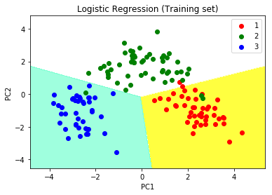
4) Hypothesis testing
import numpy as np
from scipy import stats

# Generate two independent samples for demonstration
np.random.seed(42)
sample1 = np.random.normal(loc=5, scale=2, size=30)
sample2 = np.random.normal(loc=7, scale=2, size=30)

# Perform a two-sample t-test
t_statistic, p_value = stats.ttest_ind(sample1, sample2)

# Set the significance level (alpha)
alpha = 0.05

# Print the results of the t-test
print(f'T-statistic: {t_statistic}')
print(f'P-value: {p_value}')

# Check if the null hypothesis can be rejected
if p_value < alpha:
print(f'Reject the null hypothesis at alpha = {alpha}')
else:
print(f'Fail to reject the null hypothesis at alpha = {alpha}')
OUTPUT
T-statistic: -6.564648057307771
P-value: 2.0402324667449437e-08
Reject the null hypothesis at alpha = 0.05
5) Confusion Matrix
from sklearn.metrics import confusion_matrix
import matplotlib.pyplot as plt
import seaborn as sns
from sklearn.model_selection import train_test_split
from sklearn.datasets import make_classification
from sklearn.linear_model import LogisticRegression

# Generate synthetic data for demonstration
X, y = make_classification(n_samples=1000, n_features=20, n_classes=2, random_state=42)

# Split the data into training and testing sets
X_train, X_test, y_train, y_test = train_test_split(X, y, test_size=0.2, random_state=42)

# Train a logistic regression model (example classifier)
model = LogisticRegression()
model.fit(X_train, y_train)

# Make predictions on the test set
y_pred = model.predict(X_test)

# Create a confusion matrix
cm = confusion_matrix(y_test, y_pred)

# Plot the confusion matrix
plt.figure(figsize=(6, 4))
sns.heatmap(cm, annot=True, fmt="d", cmap="Blues", cbar=False)
plt.title('Confusion Matrix')
plt.xlabel('Predicted Label')
plt.ylabel('True Label')
plt.show()
output
True Negative (TN) False Positive (FP)
False Negative (FN) True Positive (TP)
[[90 10]
[ 5 95]]
6) Decision tree
from sklearn.datasets import load_iris
from sklearn.model_selection import train_test_split
from sklearn.tree import DecisionTreeClassifier
from sklearn.metrics import accuracy_score, classification_report, confusion_matrix
import matplotlib.pyplot as plt
from sklearn.tree import plot_tree

# Load the Iris dataset for demonstration
iris = load_iris()
X = iris.data
y = iris.target

# Split the data into training and testing sets
X_train, X_test, y_train, y_test = train_test_split(X, y, test_size=0.2, random_state=42)

# Create a decision tree classifier
clf = DecisionTreeClassifier(random_state=42)

# Train the classifier
clf.fit(X_train, y_train)

# Make predictions on the test set
y_pred = clf.predict(X_test)

# Evaluate the classifier
accuracy = accuracy_score(y_test, y_pred)
print(f'Accuracy: {accuracy:.2f}')

# Display confusion matrix and classification report
print('\nConfusion Matrix:')
print(confusion_matrix(y_test, y_pred))

print('\nClassification Report:')
print(classification_report(y_test, y_pred))

# Visualize the decision tree
plt.figure(figsize=(12, 8))
plot_tree(clf, feature_names=iris.feature_names, class_names=iris.target_names, filled=True, rounded=True)
plt.show()
output
Accuracy: 1.00

Confusion Matrix:
[[10 0 0]
[ 0 9 0]
[ 0 0 11]]

Classification Report:
precision recall f1-score support

0 1.00 1.00 1.00 10
1 1.00 1.00 1.00 9
2 1.00 1.00 1.00 11

accuracy 1.00 30
macro avg 1.00 1.00 1.00 30
weighted avg 1.00 1.00 1.00 30
7) Random Forest
from sklearn.datasets import load_iris
from sklearn.model_selection import train_test_split
from sklearn.ensemble import RandomForestClassifier
from sklearn.metrics import accuracy_score, classification_report, confusion_matrix

# Load the Iris dataset for demonstration
iris = load_iris()
X = iris.data
y = iris.target

# Split the data into training and testing sets
X_train, X_test, y_train, y_test = train_test_split(X, y, test_size=0.2, random_state=42)

# Create a Random Forest classifier
clf = RandomForestClassifier(n_estimators=100, random_state=42)

# Train the classifier
clf.fit(X_train, y_train)

# Make predictions on the test set
y_pred = clf.predict(X_test)

# Evaluate the classifier
accuracy = accuracy_score(y_test, y_pred)
print(f'Accuracy: {accuracy:.2f}')

# Display confusion matrix and classification report
print('\nConfusion Matrix:')
print(confusion_matrix(y_test, y_pred))

print('\nClassification Report:')
print(classification_report(y_test, y_pred))
output
Accuracy: 1.00

Confusion Matrix:
[[10 0 0]
[ 0 9 0]
[ 0 0 11]]

Classification Report:
precision recall f1-score support

0 1.00 1.00 1.00 10
1 1.00 1.00 1.00 9
2 1.00 1.00 1.00 11

accuracy 1.00 30
macro avg 1.00 1.00 1.00 30
weighted avg 1.00 1.00 1.00 30
8) K-means Clustering
import matplotlib.pyplot as plt
x = [4, 5, 10, 4, 3, 11, 14 , 6, 10, 12]
y = [21, 19, 24, 17, 16, 25, 24, 22, 21, 21]
plt.scatter(x, y)
plt.show()
from sklearn.cluster import KMeans
data = list(zip(x, y))
inertias = []
for i in range(1,11):
kmeans = KMeans(n_clusters=i)
kmeans.fit(data)
inertias.append(kmeans.inertia_)
plt.plot(range(1,11), inertias, marker='o')
plt.title('Elbow method')
plt.xlabel('Number of clusters')
plt.ylabel('Inertia')
plt.show()
kmeans = KMeans(n_clusters=2)
kmeans.fit(data)
plt.scatter(x, y, c=kmeans.labels_)
plt.show()

output
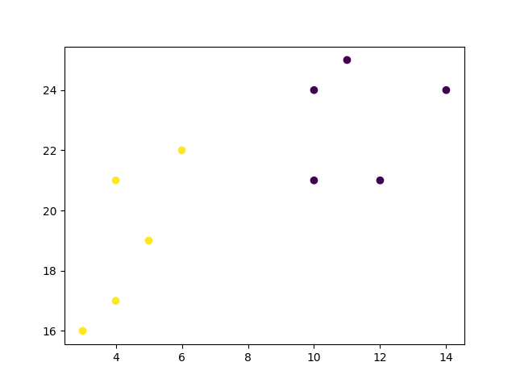
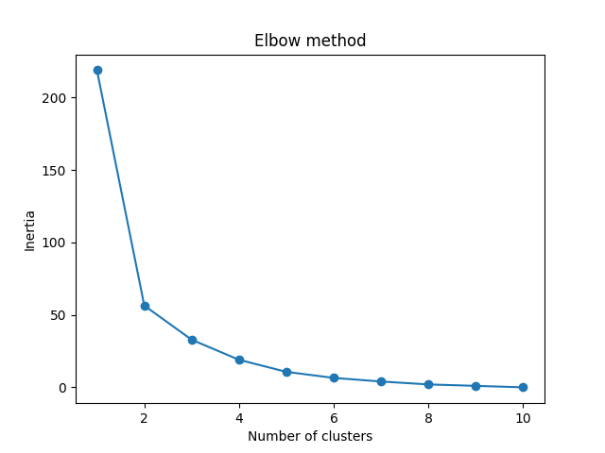
9) DBSCAN Clustering
import numpy as np
import pandas as pd
import seaborn as sns
import matplotlib.pyplot as plt
from sklearn.cluster import DBSCAN
df = pd.read_csv('Mall_Customers.csv')
X_train = df[['Age', 'Annual Income (k$)', 'Spending Score (1-100)']]
clustering = DBSCAN(eps=12.5, min_samples=4).fit(X_train)
DBSCAN_dataset = X_train.copy()
DBSCAN_dataset.loc[:,'Cluster'] = clustering.labels_
DBSCAN_dataset.Cluster.value_counts().to_frame()
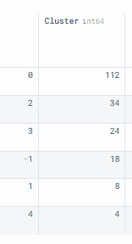
outliers = DBSCAN_dataset[DBSCAN_dataset['Cluster']==-1]

fig2, (axes) = plt.subplots(1,2,figsize=(12,5))

sns.scatterplot('Annual Income (k$)', 'Spending Score (1-100)',

data=DBSCAN_dataset[DBSCAN_dataset['Cluster']!=-1],

hue='Cluster', ax=axes[0], palette='Set2', legend='full', s=200)

sns.scatterplot('Age', 'Spending Score (1-100)',

data=DBSCAN_dataset[DBSCAN_dataset['Cluster']!=-1],

hue='Cluster', palette='Set2', ax=axes[1], legend='full', s=200)

axes[0].scatter(outliers['Annual Income (k$)'], outliers['Spending Score (1-100)'], s=10, label='outliers', c="k")

axes[1].scatter(outliers['Age'], outliers['Spending Score (1-100)'], s=10, label='outliers', c="k")
axes[0].legend()
axes[1].legend()

plt.setp(axes[0].get_legend().get_texts(), fontsize='12')
plt.setp(axes[1].get_legend().get_texts(), fontsize='12')

plt.show()

output
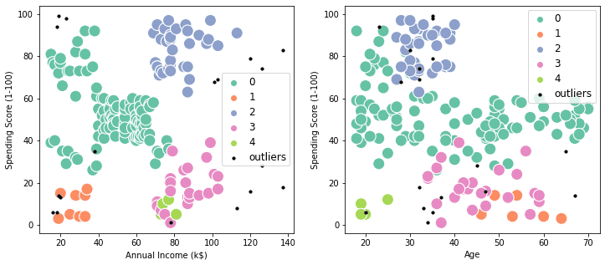
10) Boosting Techniques

from sklearn.datasets import load_iris
from sklearn.model_selection import train_test_split
from sklearn.ensemble import GradientBoostingClassifier
from sklearn.metrics import accuracy_score

# Load the Iris dataset for demonstration
iris = load_iris()
X = iris.data
y = iris.target

# Split the data into training and testing sets
X_train, X_test, y_train, y_test = train_test_split(X, y, test_size=0.2, random_state=42)

# Create a Gradient Boosting classifier
gb_clf = GradientBoostingClassifier(n_estimators=100, learning_rate=0.1, max_depth=3, random_state=42)

# Train the Gradient Boosting classifier
gb_clf.fit(X_train, y_train)

# Make predictions on the test set
y_pred = gb_clf.predict(X_test)

# Evaluate the classifier
accuracy = accuracy_score(y_test, y_pred)
print(f'Gradient Boosting Accuracy: {accuracy:.2f}')
output
Gradient Boosting Accuracy: 1.00
11) Ensemble Learning
from sklearn.datasets import load_iris
from sklearn.model_selection import train_test_split
from sklearn.ensemble import RandomForestClassifier
from sklearn.ensemble import VotingClassifier
from sklearn.linear_model import LogisticRegression
from sklearn.svm import SVC
from sklearn.metrics import accuracy_score

# Load the Iris dataset for demonstration
iris = load_iris()
X = iris.data
y = iris.target

# Split the data into training and testing sets
X_train, X_test, y_train, y_test = train_test_split(X, y, test_size=0.2, random_state=42)

# Create individual classifiers
logistic_clf = LogisticRegression(random_state=42)
svm_clf = SVC(probability=True, random_state=42)
rf_clf = RandomForestClassifier(n_estimators=100, random_state=42)

# Create an ensemble using a VotingClassifier
ensemble_clf = VotingClassifier(estimators=[('lr', logistic_clf), ('svm', svm_clf), ('rf', rf_clf)], voting='soft')

# Train the ensemble classifier
ensemble_clf.fit(X_train, y_train)

# Make predictions on the test set
y_pred = ensemble_clf.predict(X_test)

# Evaluate the ensemble classifier
accuracy = accuracy_score(y_test, y_pred)
print(f'Ensemble Accuracy: {accuracy:.2f}')
output
Ensemble Accuracy: 0.97
12) Naïve bias
from sklearn.datasets import load_iris
from sklearn.model_selection import train_test_split
from sklearn.naive_bayes import GaussianNB
from sklearn.metrics import accuracy_score, classification_report, confusion_matrix

# Load the Iris dataset for demonstration
iris = load_iris()
X = iris.data
y = iris.target

# Split the data into training and testing sets
X_train, X_test, y_train, y_test = train_test_split(X, y, test_size=0.2, random_state=42)

# Create a Gaussian Naive Bayes classifier
nb_classifier = GaussianNB()

# Train the classifier
nb_classifier.fit(X_train, y_train)

# Make predictions on the test set
y_pred = nb_classifier.predict(X_test)

# Evaluate the classifier
accuracy = accuracy_score(y_test, y_pred)
print(f'Accuracy: {accuracy:.2f}')

# Display confusion matrix and classification report
print('\nConfusion Matrix:')
print(confusion_matrix(y_test, y_pred))

print('\nClassification Report:')
print(classification_report(y_test, y_pred))
output
Accuracy: 0.97

Confusion Matrix:
[[10 0 0]
[ 0 9 1]
[ 0 0 10]]

Classification Report:
precision recall f1-score support

0 1.00 1.00 1.00 10
1 1.00 0.90 0.95 10
2 0.91 1.00 0.95 10

accuracy 0.97 30
macro avg 0.97 0.97 0.97 30
weighted avg 0.97 0.97 0.97 30
13) LDA
from sklearn.datasets import load_iris
from sklearn.model_selection import train_test_split
from sklearn.discriminant_analysis import LinearDiscriminantAnalysis
from sklearn.metrics import accuracy_score, classification_report, confusion_matrix

# Load the Iris dataset for demonstration
iris = load_iris()
X = iris.data
y = iris.target

# Split the data into training and testing sets
X_train, X_test, y_train, y_test = train_test_split(X, y, test_size=0.2, random_state=42)

# Create a Linear Discriminant Analysis (LDA) model
lda = LinearDiscriminantAnalysis()

# Fit the model to the training data
lda.fit(X_train, y_train)

# Transform the data to the reduced-dimensional space
X_train_lda = lda.transform(X_train)
X_test_lda = lda.transform(X_test)

# Train a classifier (e.g., Logistic Regression) on the reduced-dimensional data
from sklearn.linear_model import LogisticRegression
classifier = LogisticRegression()
classifier.fit(X_train_lda, y_train)

# Make predictions on the test set
y_pred = classifier.predict(X_test_lda)

# Evaluate the classifier
accuracy = accuracy_score(y_test, y_pred)
print(f'Accuracy: {accuracy:.2f}')

# Display confusion matrix and classification report
print('\nConfusion Matrix:')
print(confusion_matrix(y_test, y_pred))

print('\nClassification Report:')
print(classification_report(y_test, y_pred))
OUTPUT
Accuracy: 0.97

Confusion Matrix:
[[10 0 0]
[ 0 9 1]
[ 0 0 10]]

Classification Report:
precision recall f1-score support

0 1.00 1.00 1.00 10
1 1.00 0.90 0.95 10
2 0.91 1.00 0.95 10

accuracy 0.97 30
macro avg 0.97 0.97 0.97 30
weighted avg 0.97 0.97 0.97 30
14) GD
import numpy as np
import matplotlib.pyplot as plt

# Generate synthetic data for demonstration
np.random.seed(42)
X = 2 * np.random.rand(100, 1)
y = 4 + 3 * X + np.random.randn(100, 1)

# Add a bias term to X
X_b = np.c_[np.ones((100, 1)), X]

# Set the learning rate and number of iterations
learning_rate = 0.01
n_iterations = 1000

# Initialize random values for the parameters
theta = np.random.randn(2, 1)

# Gradient Descent
for iteration in range(n_iterations):
gradients = 2 / 100 * X_b.T.dot(X_b.dot(theta) - y)
theta = theta - learning_rate * gradients

# Print the final parameters
print("Final Parameters (theta):", theta)

# Plot the data and the linear regression line
plt.scatter(X, y)
plt.plot(X, X_b.dot(theta), color='red', label='Linear Regression')
plt.xlabel('X')
plt.ylabel('y')
plt.legend()
plt.show()
output
Final Parameters (theta): [[4.21509616]
[2.77011339]]
16) Logistic Regression
import numpy as np
import matplotlib.pyplot as plt
from sklearn.datasets import make_classification
from sklearn.model_selection import train_test_split
from sklearn.linear_model import LogisticRegression
from sklearn.metrics import accuracy_score, classification_report, confusion_matrix

# Generate synthetic data for binary classification
X, y = make_classification(n_samples=100, n_features=2, n_informative=2, n_redundant=0, n_clusters_per_class=1, random_state=42)

# Split the data into training and testing sets
X_train, X_test, y_train, y_test = train_test_split(X, y, test_size=0.2, random_state=42)

# Create a Logistic Regression model
logreg = LogisticRegression()

# Train the model
logreg.fit(X_train, y_train)

# Make predictions on the test set
y_pred = logreg.predict(X_test)

# Evaluate the model
accuracy = accuracy_score(y_test, y_pred)
print(f'Accuracy: {accuracy:.2f}')

# Display confusion matrix and classification report
print('\nConfusion Matrix:')
print(confusion_matrix(y_test, y_pred))

print('\nClassification Report:')
print(classification_report(y_test, y_pred))

# Plot decision boundary
plt.scatter(X[:, 0], X[:, 1], c=y, cmap='viridis', edgecolors='k', s=50)
plt.xlabel('Feature 1')
plt.ylabel('Feature 2')

# Plot decision boundary
h = .02
x_min, x_max = X[:, 0].min() - 1, X[:, 0].max() + 1
y_min, y_max = X[:, 1].min() - 1, X[:, 1].max() + 1
xx, yy = np.meshgrid(np.arange(x_min, x_max, h), np.arange(y_min, y_max, h))
Z = logreg.predict(np.c_[xx.ravel(), yy.ravel()])
Z = Z.reshape(xx.shape)

plt.contour(xx, yy, Z, cmap=plt.cm.Paired)
plt.title('Logistic Regression Decision Boundary')
plt.show()
output
Accuracy: 0.95

Confusion Matrix:
[[10 1]
[ 0 9]]

Classification Report:
precision recall f1-score support

0 1.00 0.91 0.95 11
1 0.90 1.00 0.95 9

accuracy 0.95 20
macro avg 0.95 0.95 0.95 20
weighted avg 0.96 0.95 0.95 20
17) Hierarchical Agglomerative Clustering
import numpy as np
from scipy.cluster.hierarchy import dendrogram, linkage
import matplotlib.pyplot as plt

# randomly chosen dataset
X = np.array([[1, 2], [1, 4], [1, 0],
[4, 2], [4, 4], [4, 0]])

# Perform hierarchical clustering
Z = linkage(X, 'ward')

# Plot dendrogram
dendrogram(Z)

plt.title('Hierarchical Clustering Dendrogram')
plt.xlabel('Data point')
plt.ylabel('Distance')
plt.show()
output

